SIMATS ENGINEERING (SAVEETHA SCHOOL OF ENGINEERING)
Department of Artificial Intelligence and Data Science
ASSESSMENT TOOL 1 – Experiments

Course Code: | DSA03o5 | Course Title: | Natural Language Processing
CO Assessed: | CO3 – Precision | Assessment: | Assessment Tool 1 – Experiments
Weightage: | 50% of CIA
CO5 Statement: | Apply N-gram models, smoothing techniques, part-of-speech tagging systems and to evaluate effective syntactic analysis. (BL-3)
Student Name: | P. Mahendra Reddy | Reg. No.: | 192425261
Section / Batch: | B. Tech _ AI & Ml | Date: | 08/08/2026

Code of Conduct
I P. Mahendra Reddy (192425261) certify that this submission is my original work and that I have adhered to the guidelines specified for this assessment. I understand that any violation of academic integrity rules will result in disciplinary action.
Signature of the Student: _________________________

Instructions
- Perform all experiments using Google Colab.
- Create a separate notebook (.ipynb) for the assessment.
- Ensure all code is executable without errors.
- Include appropriate comments explaining the logic used.
- Complete all three experiments in a single Google Colab notebook.
- Execute all cells and display the outputs for the given test cases.
- Save the notebook with the naming convention: RegNo_Name_CO3-AT1.ipynb
- Upload the notebook to your GitHub repository.
- Ensure the repository is public or accessible to the instructor.
- Submit the following:
- GitHub Repository Link in GCR
- Google Colab Share Link in GCR
- Screenshots of uploaded coding and output files as printout.
- Duration: 30 minutes.

Section / Topic | Focus |  | Experiment Questions
Context-Free Grammars for English Syntax, Context-Free Rules and Trees, Sentence-Level Constructions, Parsing, Top-Down Parsing, Earley Parsing |  | Design a Python program to validate sentences using CFG production rules and construct parse tree representations for valid sentences. | Q1
Agreement, Feature Structures, Sub Categorization |  | Design a Python program to verify subject–verb agreement and validate grammatical constraints using feature structures and subcategorization rules. | Q2
Probabilistic Context-Free Grammars (PCFGs) |  | Design a Python program to parse sentences and compute sentence probabilities using probabilistic grammar production rules. | Q3

Annexure A – Experiments

Experiment 1: Context-Free Grammar Rule Validation and Parse Tree Construction

Experiment Description
Design a Python program to validate whether a sentence follows the given Context-Free Grammar (CFG) rules and generate its parse tree representation.
Grammar:
S → NP VP
NP → Det N
VP → V NP
Det → the | a
N → student | teacher | book
V → reads | likes

Task
- Accept a sentence as input.
- Verify whether it conforms to the CFG.
- Construct and return the parse tree.
- Return "Invalid Sentence" if parsing fails.

Function Prototype
def parse_cfg(sentence):
pass

Test Cases
Input | Expected Output
the student reads a book | Valid Parse Tree
a teacher likes the book | Valid Parse Tree
student reads book | Invalid Sentence
the book likes a teacher | Valid Parse Tree
reads the student book | Invalid Sentence

Experiment 2: Agreement and Feature Structure Checking

Experiment Description
Design a Python program that verifies subject–verb agreement using feature structures containing Number and Person attributes.

Feature Rules
he → singular, third person
she → singular, third person
it → singular, third person
they → plural
runs → singular verb
writes → singular verb
run → plural verb
write → plural verb

Task
- Accept Subject and Verb.
- Compare feature structures.
- Return True if agreement holds.
- Return False otherwise.

Function Prototype
def check_agreement(subject, verb):
pass

Test Cases
Subject | Verb | Expected
he | runs | True
he | run | False
they | run | True
they | writes | False
she | writes | True

Experiment 3: Probabilistic Context-Free Grammar (PCFG) Parsing

Experiment Description
Implement a Python program to compute the probability of a sentence using the given PCFG.

Grammar
S → NP VP [1.0]
NP → John [0.6]
NP → Mary [0.4]
VP → runs [0.5]
VP → walks [0.5]

Probability Formula
P(Sentence)
=
P(S→NP VP)
× P(NP)
× P(VP)

Task
- Accept a two-word sentence.
- Parse using the PCFG.
- Compute sentence probability.
- Return 0 if sentence cannot be generated.

Function Prototype
def sentence_probability(sentence):
pass

Test Cases
Input Sentence | Expected Probability
John runs | 0.30
John walks | 0.30
Mary runs | 0.20
Mary walks | 0.20
Peter runs | 0.00

Experiment 1: CFG Rule Validation and Parse Tree Construction
Aim
To design and implement a Python program to validate whether a given sentence conforms to the specified Context-Free Grammar (CFG) rules and construct its corresponding parse tree.
Algorithm
- Start the program.
- Accept a sentence from the user.
- Split the sentence into individual words.
- Define the CFG rules:
  - S → NP VP
  - NP → Det N
  - VP → V NP
  - Det → the | a
  - N → student | teacher | book
  - V → reads | likes
- Check whether the sentence contains exactly five words.
- Verify the first noun phrase using the pattern Det N.
- Verify the verb phrase using the pattern V NP.
- If all the words satisfy the grammar rules, construct the parse tree.
- Otherwise, return "Invalid Sentence".
- Stop the program.
Program
def parse_cfg(sentence):
words = sentence.split()

determiners = ["the", "a"]
nouns = ["student", "teacher", "book"]
verbs = ["reads", "likes"]

if len(words) != 5:
return "Invalid Sentence"

det1, noun1, verb, det2, noun2 = words

if (det1 in determiners and
noun1 in nouns and
verb in verbs and
det2 in determiners and
noun2 in nouns):

parse_tree = {
"S": {
"NP": {
"Det": det1,
"N": noun1
},
"VP": {
"V": verb,
"NP": {
"Det": det2,
"N": noun2
}
}
}
}

return parse_tree

return "Invalid Sentence"

sentence = input("Enter a sentence: ")

result = parse_cfg(sentence)

print("Result:")
print(result)

output:

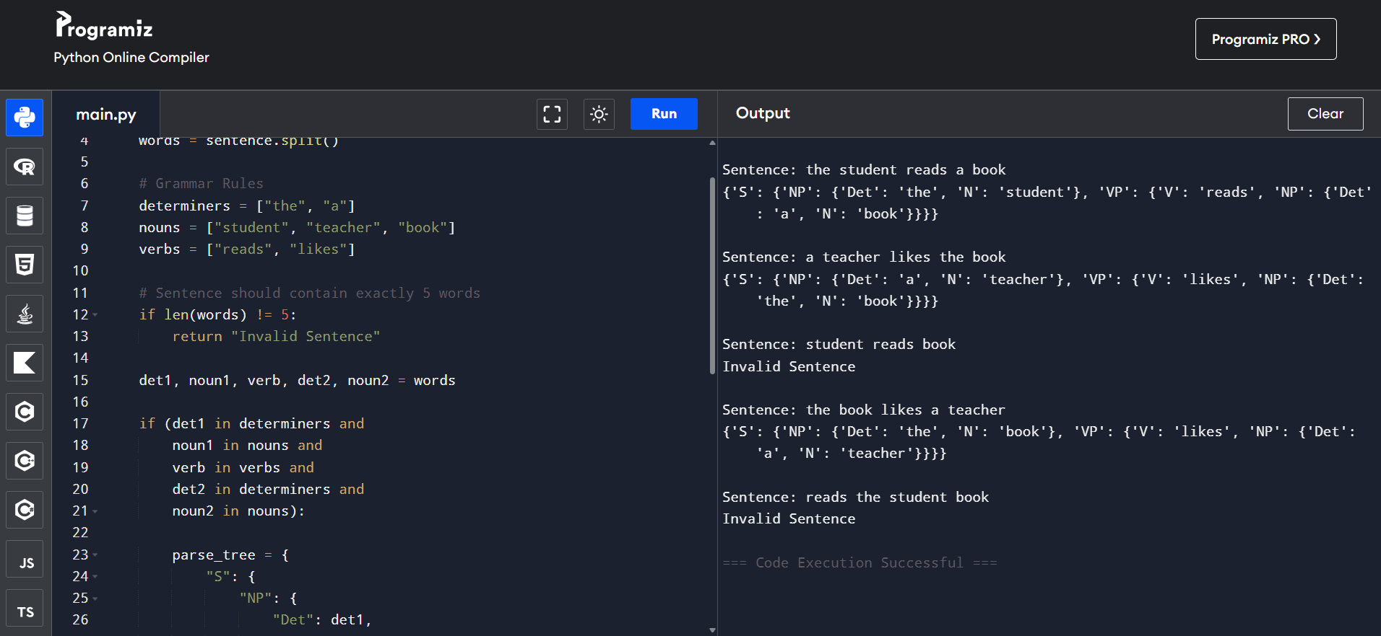

Experiment 2: Agreement and Feature Structure Checking
Aim
To design and implement a Python program to verify subject–verb agreement using feature structures containing Number and Person attributes.
Algorithm
- Start the program.
- Accept the subject and verb as input.
- Define the feature structure for subjects:
  - he → singular, third person
  - she → singular, third person
  - it → singular, third person
  - they → plural
- Define the corresponding features for verbs:
  - runs → singular
  - writes → singular
  - run → plural
  - write → plural
- Check whether the given subject and verb exist in the feature structures.
- Compare the number features of the subject and verb.
- If the features match, return True.
- Otherwise, return False.
- Stop the program.
Program
def check_agreement(subject, verb):

subject_features = {
"he": "singular",
"she": "singular",
"it": "singular",
"they": "plural"
}

verb_features = {
"runs": "singular",
"writes": "singular",
"run": "plural",
"write": "plural"
}

if subject not in subject_features:
return False

if verb not in verb_features:
return False

return subject_features[subject] == verb_features[verb]

subject = input("Enter subject: ")
verb = input("Enter verb: ")

result = check_agreement(subject, verb)

print("Agreement:", result)
Sample Input
Enter subject: he
Enter verb: runs
Sample Output
Agreement: True
Another Sample Input
Enter subject: he
Enter verb: run
Output
Agreement: False

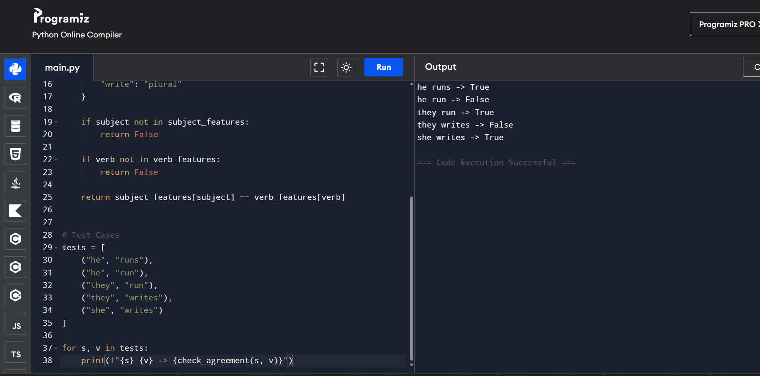

Experiment 3: Probabilistic Context-Free Grammar (PCFG) Parsing
Aim
To design and implement a Python program to calculate the probability of a sentence using a Probabilistic Context-Free Grammar (PCFG).
Algorithm
- Start the program.
- Accept a two-word sentence from the user.
- Define the PCFG probabilities:
  - S → NP VP [1.0]
  - NP → John [0.6]
  - NP → Mary [0.4]
  - VP → runs [0.5]
  - VP → walks [0.5]
- Split the sentence into two words.
- Check whether the first word can be generated by the NP rule.
- Check whether the second word can be generated by the VP rule.
- If either word is not present in the grammar, return probability 0.
- Otherwise, calculate:
P(Sentence) = P(S → NP VP) × P(NP) × P(VP)
- Return the calculated probability.
- Stop the program.
Program
def sentence_probability(sentence):

noun_probabilities = {
"John": 0.6,
"Mary": 0.4
}

verb_probabilities = {
"runs": 0.5,
"walks": 0.5
}

words = sentence.split()

if len(words) != 2:
return 0.0

noun, verb = words

if noun not in noun_probabilities:
return 0.0

if verb not in verb_probabilities:
return 0.0

probability = (
1.0 *
noun_probabilities[noun] *
verb_probabilities[verb]
)

return probability

sentence = input("Enter a sentence: ")

probability = sentence_probability(sentence)

print("Sentence Probability:", probability)
Sample Input
Enter a sentence: John runs
Sample Output
Sentence Probability: 0.3
Another Sample Input
Enter a sentence: Mary walks
Output
Sentence Probability: 0.2

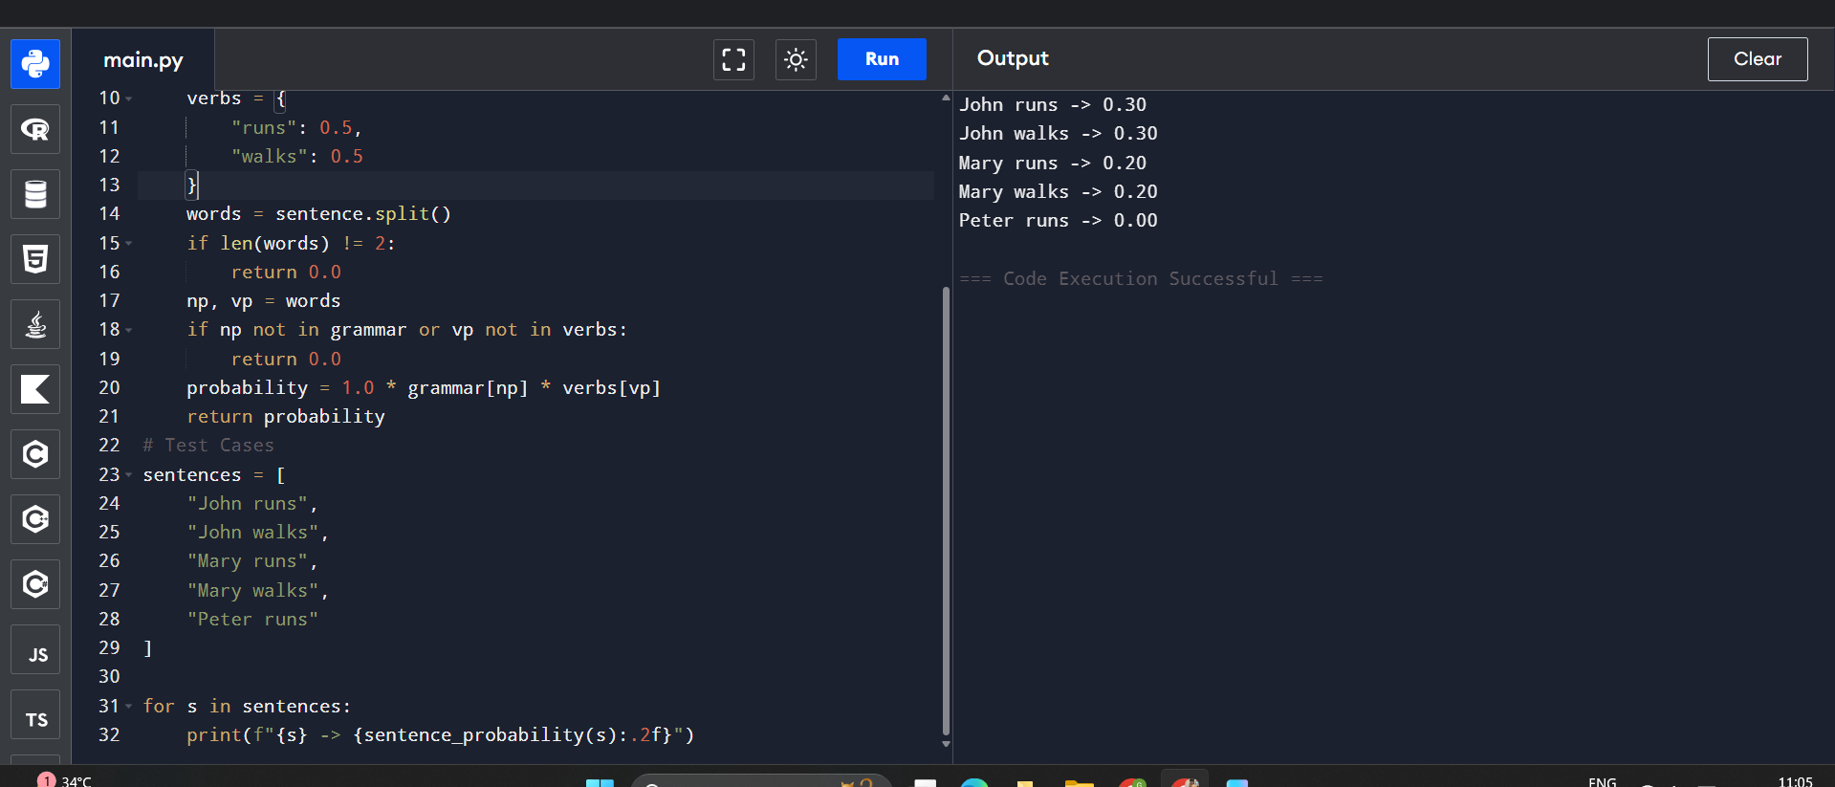

Rubrics for Calculation

Criteria | Weightage | Level 4 – Exemplary | Level 3 – Proficient | Level 2 – Developing | Level 1 – Beginning
Understanding of Concepts | 25 | Demonstrates thorough understanding and effectively integrates multiple concepts/technologies | Good understanding with proper integration of most concepts | Basic understanding; limited or partial integration | Poor understanding; unable to integrate concepts
Experimental Design | 30 | Well-planned, systematic implementation with optimal solution | Correct implementation with minor issues | Basic implementation with errors or inefficiencies | Incorrect or incomplete implementation
Use of Tools | 20 | Effective and advanced use of tools/technologies with proper configuration | Appropriate use of tools with correct execution | Limited or inconsistent use of tools | Incorrect or minimal use of tools
Analysis of Results | 15 | Insightful analysis with accurate interpretation and validation of results | Good analysis with reasonable interpretation | Basic analysis with limited insights | Poor or incorrect analysis of results
Documentation | 10 | Clear, well-structured documentation with diagrams, code, and results | Organized documentation with necessary details | Basic documentation with missing details | Poor or incomplete documentation

Q. No. / Criteria Level | Understanding of Concepts | Experimental Design | Use of Tools | Analysis of Results | Documentation | Sub. Total | Total %
1
2
3

Faculty In-charge | Course Coordinator | Program Director
Signature: _______________ | Signature: _______________ | Signature: _______________
Date: ___________________ | Date: ___________________ | Date: ___________________

